Half Adder :-
A combinational Circuit that performs the addition of bits is called half adder. This circuit needs two binary inputs and two binary outputs. The input variable product the sum (S) and Carry (C) .
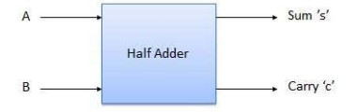

Fig. :- Block diagram
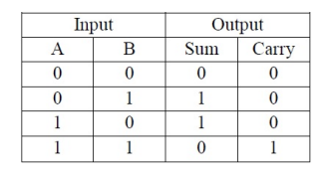
Truth Table :-

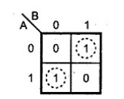
K-Map for SUm K-Map for Sum K-Map For Carry
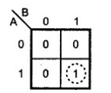

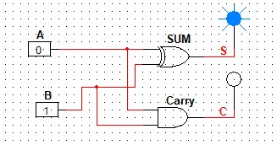
Expression from the K-map
Sum = AB’ + A’B
Carry = AB
:- Logical diagram

